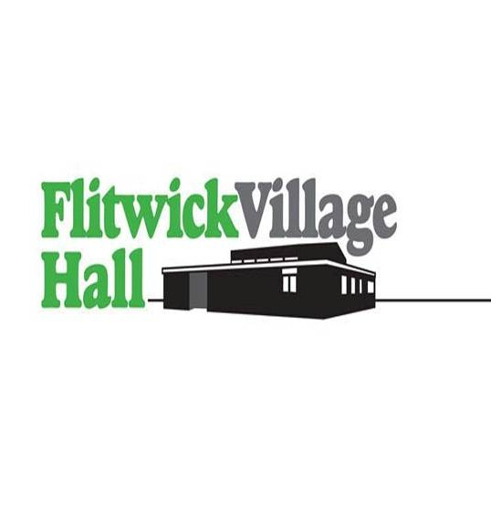
Booking Form
www.flitwickvillage hall.co.uk
Booking Officer:- Sarah Nguyen
Telephone Number:- 07768 785057
Email:- flitwickvillagehallbookings@gmail.com
Name of Applicant_____________________________________________
Address___________________________________________________________________________
Telephone number__________________________________________________________________
Email address_______________________________________________________________________
Organisation_______________________________________________________________________
If you would like to advertise your event or group on our website please contact flitwickvillagehallbookings@gmail.com
If you would like to share your event with the community upload the details for free at: https://www.flitwick.gov.uk/whats-on/calendar-of-events/upload-an-event/
PLEASE ENTER YOUR REQUIREMENTS
Date required | Hours required  From-To | Main Hall | Dining Room | Rear  Conference  Room | Purpose of hiring | Hire charge
Do you require use of the kitchen? YES/NO
Do you require use of the stage? YES/NO
Will you be having a bouncy castle? YES/NO
Do you intend to have a Licensed bar to sell alcohol? YES/NO
If ‘yes’ then the hirer needs to apply for a ‘Temporary events notice’ (TEN)
See ‘Terms and conditions’ Section 7A for further information

Chairs and Tables | # of CHAIRS | # of  TABLES
I acknowledge the conditions of hiring have been produced to and read by me and I understand that the hirer is bound by the conditions and, in particular, is responsible for any loss or damage which may occur during hiring.

Signed____________________________________ Date______________________________
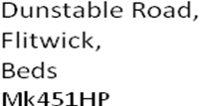
www.flitwickvillagehall.co.uk
DATA PROTECTION SIGN OFF
FLITWICK VILLAGE HALL
Data Protection Act: Hirers Consent form
Permission to store and process your data
To comply with the Data Protection Act (1998) we must ask your permission to store and process your personal and sensitive data.
What is personal and sensitive data?
Personal data is data which can be used to identify you. This may include your name, date of birth, address, telephone number, email address, photo’s, social media etc.
How will we use this data?
Your data will only be used for the purpose of providing information for Flitwick Village Hall Management Committee. We will not share your personal data with any third party.
We will only ever share your information with your permission, for the purposes we have stated (unless required to do so by law).
Name________________________-
Address__________________________________________________________
Phone________________
Email_____________________________________
Date_______________________
Signature __________________________________

