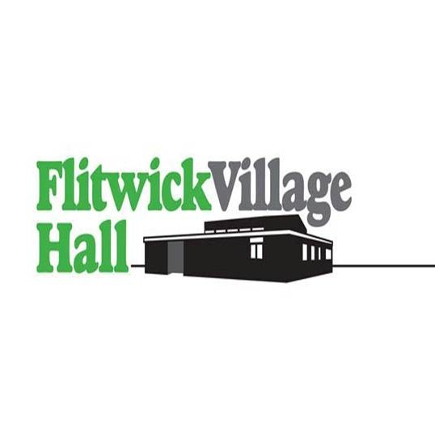
Booking Form
www.flitwickvillagehall.co.uk

Booking Officer:- Sarah Nguyen, 10 The Ridgeway, Flitwick, Beds, MK45 1DH
Telephone Number:- 07768 785057

Email:- flitwickvillagehallbookings@gmail.com
Applicant Name__________________________________________________________________
Address___________________________________________________________________________
Telephone number__________________________________________________________________
Email address_______________________________________________________________________
Organisation_______________________________________________________________________
If you would like to advertise your event or group on our website please contact flitwickvillagehallbookings@gmail.com
If you would like to share your event with the community upload the details for free at: https://www.flitwick.gov.uk/whats-on/calendar-of-events/upload-an-event/
PLEASE ENTER YOUR REQUIREMENTS – Please add dates to the form on p.2
Day required | Hire  Start—Finish  Time | Main Hall | Front  Cttee Room | Rear  Room | Purpose of hiring | Hire charge
Do you require use of the kitchen? YES/NO
Do you require the Dining room? YES /NO
Do you require the stage? YES/NO
Please indicate if you require the bar to sell alcohol:- Yes/No
If ‘yes’ then the organiser needs to apply for a ‘Temporary events notice’ (TEN)
See ‘Terms and conditions’ section 7, for further information.
Please note: the Hall does not have a licence to sell alcohol.

Chairs & Tables | No of CHAIRS | No of TABLES  Own layout  Yes /No

I acknowledge the conditions of hiring have been produced to and read by me and I understand that the hirer is bound by the conditions and, in particular, is responsible for any loss or damage which may occur during hiring. The hire ‘Terms & Conditions ’are available on our web site.
Block bookings will be invoiced monthly as detailed in the terms and conditions.

Signed____________________________________ Date______________________________

Day | Date | Day | Date
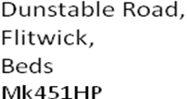
www.flitwickvillagehall.co.uk
DATA PROTECTION SIGN OFF
FLITWICK VILLAGE HALL
Data Protection Act: Hirers Consent form
Permission to store and process your data
To comply with the recent changes to the Data Protection Act (1998)we must ask your permission to store and process your personal and sensitive data.
What is personal and sensitive data?
Personal data is data which can be used to identify you. This may include your name, date of birth, address, telephone number, email address, photo’s, social media etc.
How will we use this data?
Your data will only be used for the purpose of providing information for Flitwick Village Hall Management Committee. We will not share your personal data with any third party.
We will only ever share your information with your permission, for the purposes we have stated (unless required to do so by law)
Name________________________-
Address__________________________________________________________
Phone________________
Email_____________________________________
Date_______________________
Data Protection sign off
Signature __________________________________
If you are happy for us to display your name and contact telephone number on the display sheets in the foyer please sign below:
Signature __________________________________

